

SMART   
PILL   
DISPENSER

# Project Report

Smart pill dispenser

Winter Sem 2022-23

ECS1002

Submitted by

## Aditya Patil – 20BCE7013

## Dhyan –20bce7648

## Ivan christopher – 20BCI7097

## jeevantika Gurung – 20BCR7087

## khajan – 20BES7003

## priyam – 20BES7012

# guided by

## dr. ambuj sharma

## Picture 8

## INDEX

## Abstract 1

## Introduction 2

## problem definition 2

## Objective 4

## Methodology 4-9

## result 10

## conclusion 11

## references 12

## codes 12

|  |
| --- |
| Abstract |

This report presents the design and development of a smart pill dispenser to assist individuals with autism, the elderly, and people with disabilities in managing their medication and overall health. The aim of this project is to create an innovative solution to tackle the issue of missed or incorrect medication doses that can result in serious health complications for these vulnerable populations.

The smart pill dispenser has been designed to be compact, user-friendly, and easy to operate, making it accessible to people of all ages and abilities. The box is equipped with advanced features such as a mobile app that can save pill configurations, real-time updating using cloud services, and pill consumption reminders.

This smart pill dispenser serves as an essential tool for ensuring the health and well-being of individuals with autism, the elderly, and people with disabilities. By reducing the risk of missed or incorrect doses of medicine, this project will have a significant impact on the quality of life for these populations.

|  |
| --- |
| Introduction |

Medication management is a crucial aspect of maintaining good health, especially for induvial with autism, the elderly, and people with disabilities. These populations often require medication for various medical conditions, and any missed or incorrect doses can lead to serious health complications. However, managing medication can be challenging, especially for those with cognitive or physical impairments.

The aim of this project is to design and develop a mobile smart pill box to assist individuals with autism, the elderly, and people with disabilities in managing their medication and overall health. The smart pill box is designed to be user-friendly, compact, and equipped with advanced features to make it accessible to people of all ages and abilities.

# problem definition

The problem this project aims to solve is the difficulty faced by individuals who are visually impaired, hearing impaired, or have autism in managing their medication. These populations often require assistance from a caregiver to take their medication, which can be inconvenient and may compromise their privacy. Missed or incorrect doses of medication can have serious consequences for these populations, including worsening of their health condition or potential hospitalization. The smart pill dispenser provides a solution to this problem by allowing individuals to manage their medication independently and effectively. The device is easy to operate and can be customized to accommodate individual pill configurations, making it accessible to people of all ages and abilities.

# objectives

* To design and develop a smart pill dispenser that can be easily operated by individuals with visual, hearing, or cognitive impairments.
* To create an Android application that can be used to input and store pill configuration details and establish a connection with AWS S3 cloud storage.
* To develop a backend infrastructure using AWS services such as Lambda, SNS, and S3 to store and manage pill configuration data.
* To integrate the smart pill dispenser with the Raspberry Pi to enable timely and accurate dispensing of medication.
* To create an alarm system and LED flash mechanism that will alert users to the appropriate dosage and timing of their medication.
* To incorporate an IR sensor to identify the container and dispense the correct amount of medication.
* To test the device and app for accuracy, usability, and reliability in dispensing medication according to individualized pill configurations.
* To evaluate the user experience and satisfaction with the smart pill dispenser and make necessary adjustments based on feedback.
* To provide an affordable and accessible solution for medication management that improves the quality of life for individuals with visual, hearing, or cognitive impairments.

# Methodology/Procedure

* Research existing smart pill dispenser technologies and available resources for developing the project.
* Conduct a needs assessment to identify the specific requirements of individuals with visual, hearing, or cognitive impairments in managing their medication.
* Design a prototype of the smart pill dispenser and test its functionality with a Raspberry Pi, IR sensor, SG motors, and display.
* Develop an Android application that can be used to input and store pill configuration details and establish a connection with AWS S3 cloud storage.

# Mobile APP (Android Studio)

## smart pill dispenser(ui)

* Android OS: 11.0 (R) - API 30
* Development Platform: Android Studio
* Minimum SDK: 32
* RAM Required (Min): 4
* Internet Connectivity

## 

* Create a backend infrastructure using AWS services such as Lambda, SNS, and S3 to store and manage pill configuration data.

# Cloud service (AWS)

## Simple storage service(s3)

## 

## Lambda function

## 

## Simple notification service(sns)

## 

## 

* Integrate the smart pill dispenser with the Raspberry Pi and establish communication between the dispenser and the Android app using Wi-Fi connectivity.
* Develop an alarm system and LED flash mechanism that will alert users to the appropriate dosage and timing of their medication.
* Incorporate an IR sensor to identify the container and dispense the correct amount of medication.
* Test the device and app for accuracy, usability, and reliability in dispensing medication according to individualized pill configurations.

# Smart pill box

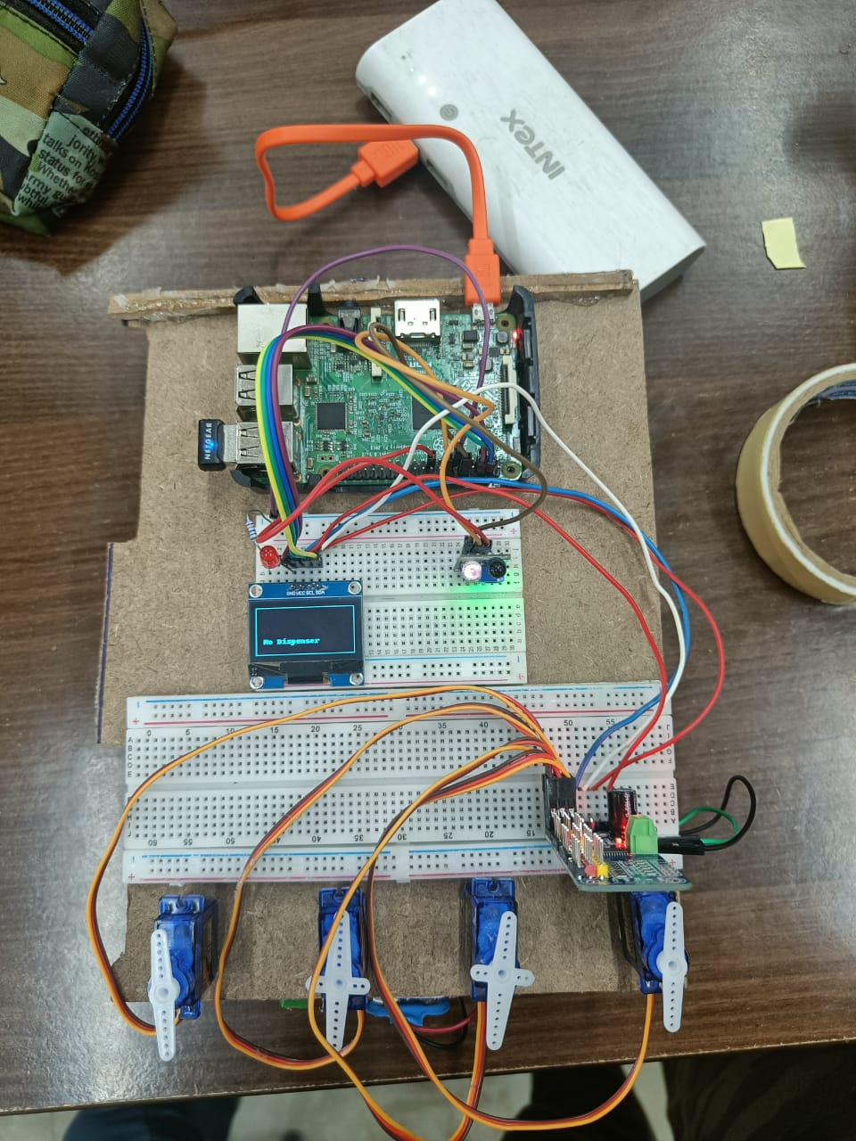

* Evaluate the user experience and satisfaction with the smart pill dispenser through user testing and feedback.
* Make necessary adjustments to the device and app based on user feedback and repeat testing as needed.

# Results and Discussion

The smart pill dispenser was successfully designed and developed to assist individuals with visual, hearing, or cognitive impairments in managing their medication. The dispenser was able to hold up to 5 types of pills and could be easily configured through an Android app, allowing users to input pill configuration details such as name, pill ID, dosage, and time. These details were then stored in AWS S3 cloud storage, which triggered a Lambda function to send reminders to the user's registered email address via AWS SNS service.

The dispenser was powered by a Raspberry Pi and equipped with an IR sensor, SG motors, and display. The Raspberry Pi received the pill configuration details, and when the specified time was reached, an alarm was triggered to alert visually impaired users, and an LED was flashed for users with hearing impairments. The dispenser accurately dispensed the appropriate number of pills into a container identified by an IR sensor, ensuring that users received the correct dosage at the appropriate time.

Testing showed that the device and app were accurate, reliable, and easy to use. User testing and feedback helped to identify areas for improvement, including enhancing the alarm system and LED flash mechanism and making the Android app more user-friendly.

Overall, the smart pill dispenser was able to provide an affordable and accessible solution for medication management, improving the quality of life for individuals with visual, hearing, or cognitive impairments. The successful development of this technology demonstrates the potential for further innovation in assistive technologies to enhance the lives of people with disabilities.

# Conclusion and future scope

**Conclusion:**

In conclusion, the development of the smart pill dispenser represents a significant contribution to assistive technology for individuals with visual, hearing, or cognitive impairments. The device provides a simple and effective solution for managing medication and can significantly reduce the risk of missed or incorrect doses. The Android app and cloud storage system enable easy customization and update of medication details, while the Raspberry Pi-based dispenser accurately dispenses the appropriate number of pills at the right time. This innovative solution has the potential to improve the quality of life for many people and offers a practical solution to a significant problem.

**Future Scope:**

While this project has been successful in developing a working prototype, there is still potential for further enhancements and improvements. Here are some future scope possibilities:

Integration with wearable devices: The smart pill dispenser could be integrated with wearable devices to provide real-time monitoring of vital signs such as heart rate and blood pressure. This integration could help identify patterns and ensure timely medication administration.

Expansion of functionality: The device could be expanded to include other features such as temperature and humidity sensors to ensure proper storage conditions for medication.

Integration with other healthcare providers: The device could be linked to the healthcare provider's electronic medical record system, ensuring timely medication adherence monitoring, and timely communication with healthcare providers.

Integration with voice assistants: The smart pill dispenser could be integrated with voice assistants, making it more accessible to individuals with cognitive and visual impairments.

# References

1. K: https://smartech.gatech.edu/bitstream/handle/1853/45009/

MedicationDeliveryTechReport.pdf?sequence=1&isAllowed=y

2. <https://rspsciencehub.com/pdf_1405_1b9b149b2d622ace45d58a7a466f7783.html>

3. https://www.researchgate.net/profile/Haifeng-Wang-25/publication/319688945_Drug_Dispenser_Replenishment_Optimization_via_Mixed_Integer_Programming_in_Central_Fill_Pharmacy_Systems/links/59b98fad458515bb9c48a302/Drug-Dispenser-Replenishment-Optimization-via-Mixed-Integer-Programming-in-Central-Fill-Pharmacy-Systems.pdf

4. https://www.researchgate.net/profile/Haifeng-Wang-25/publication/319688945_Drug_Dispenser_Replenishment_Optimization_via_Mixed_Integer_Programming_in_Central_Fill_Pharmacy_Systems/links/59b98fad458515bb9c48a302/Drug-Dispenser-Replenishment-Optimization-via-Mixed-Integer-Programming-in-Central-Fill-Pharmacy-Systems.pdf

# COdes

